Project Report: Helpmate AI Application

Introduction
In this project, we have developed the Helpmate AI application, designed to assist users in searching for information within a collection of documents. The application's primary goal is to provide a user-friendly platform for searching and retrieving information from a large collection of documents. To achieve this, various components have been implemented, each serving a specific purpose.
Implementation Details
The application employs several libraries to carry out various tasks, including:
numpy and pandas: for data manipulation.
pdfplumber: for extracting text from PDF documents.
pathlib: for file path handling.
operator: for sorting and data manipulation.
json: for handling JSON data.
tiktoken: for tokenizing text data.
openai: for utilizing OpenAI's text embedding model.
chromadb: for creating a document database.
re: for working with regular expressions.

Data Extraction from PDF
We start the code by importing the required libraries and define a function, extract_pdf_sections_to_df which is responsible for extracting sections and content from the PDF document. This function identifies sections based on a specific pattern and assembles the extracted data into a DataFrame. Recursive extraction is applied to the "PART IV - BENEFITS" section to split it into subsections.
Metadata Extraction
Metadata is associated with each page of the extracted content. This metadata includes the policy name and section number, and this information is stored in a new column within the DataFrame.
Document Embedding
Document embedding is a crucial aspect of the application, as it enables efficient searching. OpenAI's embedding model is utilized for this purpose. The following steps are involved:
- An embedding function is established using the OpenAI embedding model.
- A collection named 'RAG_on_Policy' in ChromaDB is created, utilizing the embedding function to embed the documents.
- The text content and metadata are converted to lists to be passed to ChromaDB.
- The text data is added to the collection, along with unique IDs and associated metadata.
- Users can query this collection to retrieve relevant documents.

Cache Mechanism
To enhance search efficiency, the application includes a cache mechanism. This mechanism stores previous query results, and if a new query closely matches a cached query, it retrieves results from the cache instead of the main collection. The following steps are involved:
- A user query is input.
- The cache collection is queried first, and if a match is found, the results are returned directly from the cache.
- If no match is found in the cache, a main collection query is performed, and the results are stored in the cache for future use.
- A threshold is set to determine when to use the cache or the main collection results.
Additionally, we tried to improve the relevance and ranking of search results obtained from a semantic search by using a pre-trained CrossEncoder model.

Improving Semantic Search Results
To enhance the relevance and ranking of search results, the following steps were taken:
- The CrossEncoder model from the sentence_transformers library was imported to rank sentence pairs.
- A pre-trained CrossEncoder model, 'cross-encoder/ms-marco-MiniLM-L-6-v2,' was initialized for scoring sentence pairs.
- Pairs of the user query and each of the top 20 search results were created and stored in the cross_inputs list.
- The CrossEncoder model was used to score these input pairs to measure how well each response aligns with the user's query, and the results were stored in cross_rerank_scores.
- The computed rerank scores were added as a new column, 'Reranked_scores,' in the results_df DataFrame, allowing for improved ranking of search results based on relevance to the query.

Returning the Top 3 Results from Semantic Search
The code sorted the results_df DataFrame by the 'Distances' column in ascending order, presumably representing the semantic similarity between the user query and search results. The top 3 results with the smallest distances were selected and stored in the top_3_semantic DataFrame.

Generating Responses
A function, generate_response, was defined to create responses using GPT-3.5's ChatCompletion based on the user query and the retrieved information. It combined the user query with relevant information from the top 2 documents. A conversation prompt was constructed, specifying system instructions, the user's query, and the content of the top 2 documents. Messages were prepared in the required format for the ChatCompletion model, specifying roles (system, user, assistant) and content. The response was generated from the GPT-3.5 model by providing the messages as input, and the response text was extracted.
Here are the outcomes in form of screenshots:

Query 1
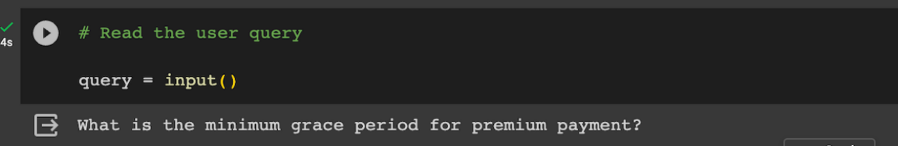

Semantic Search Results
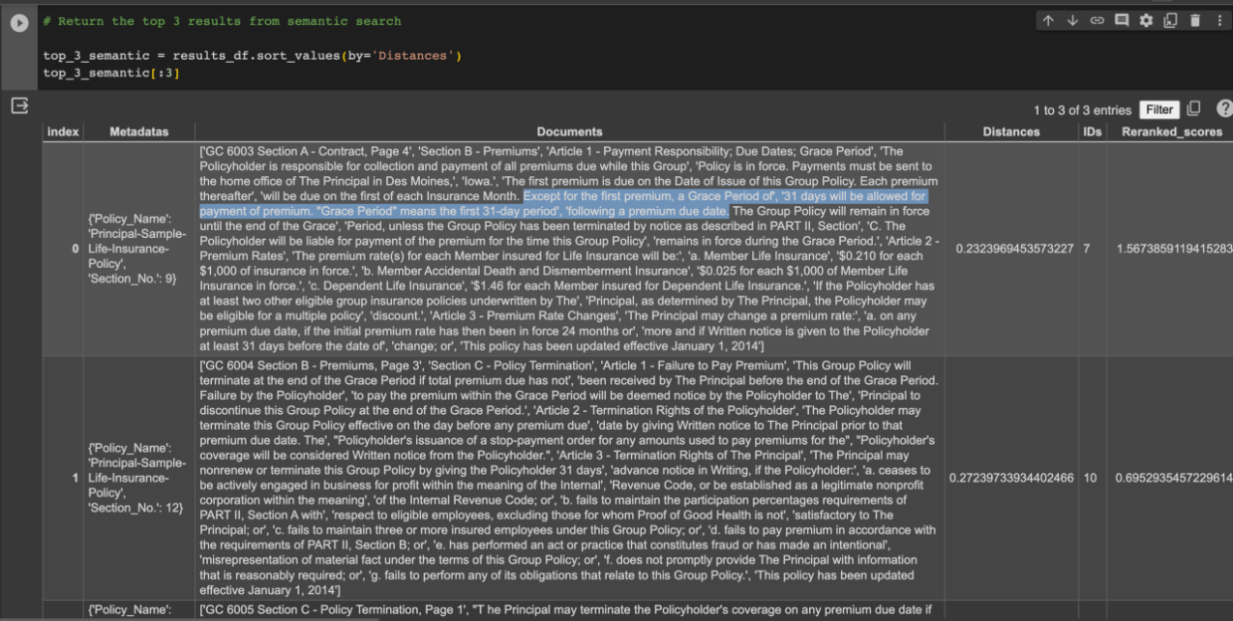

Generative Search Results
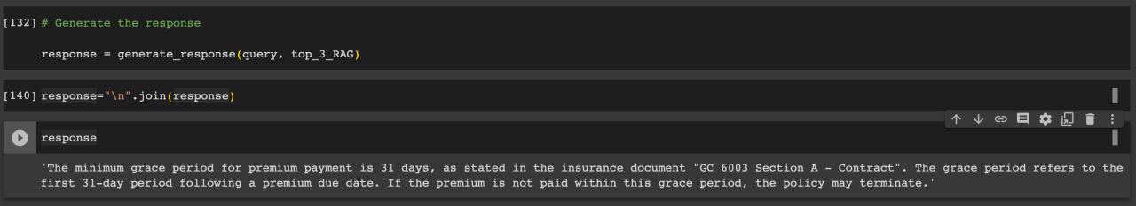

Query 2
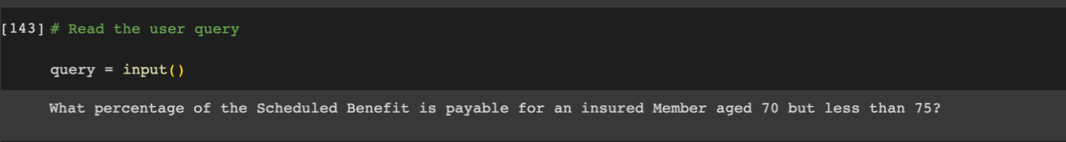

Semantic Search Results
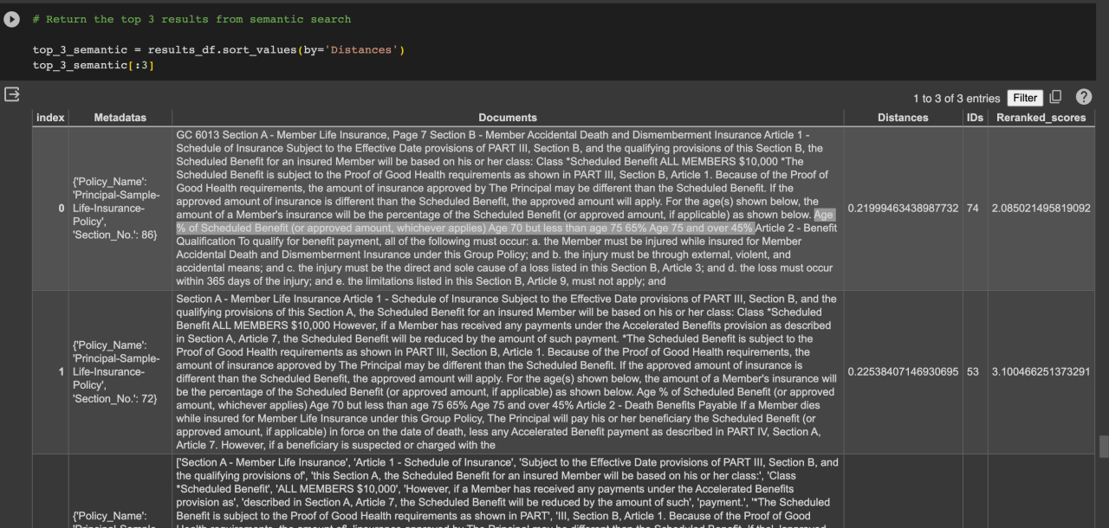

Generative Search Results
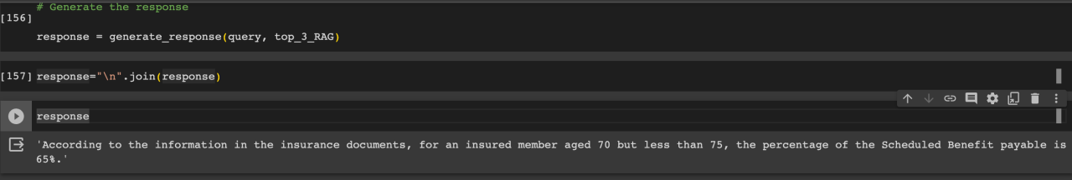

Query 3
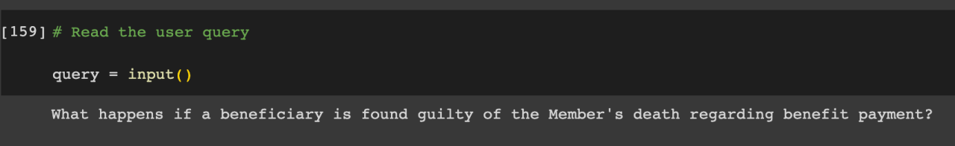

Semantic Search Results
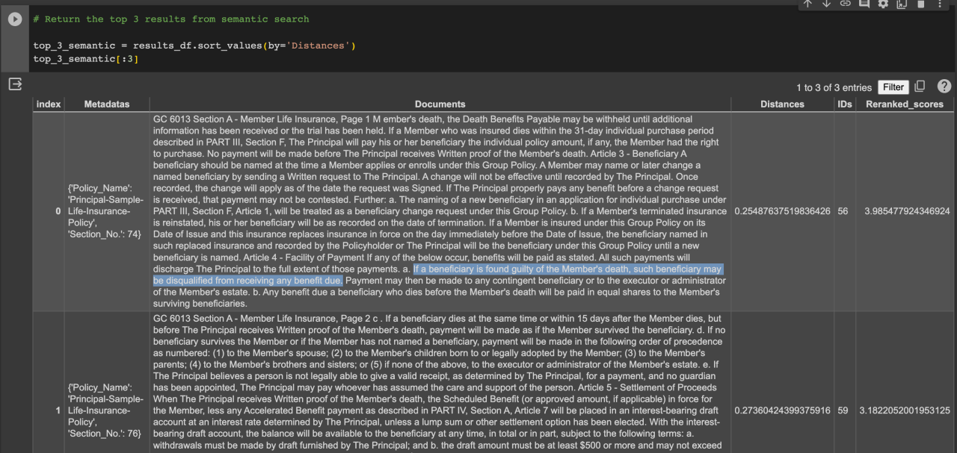

Generative Search Results
